HOMECHEF WEB APPLICATION
INSTANT ACCESS TO HOME COOKED MEALS

ABSTRACT
The increasing prevalence of unhealthy eating habits, largely driven by urbanization, busy lifestyles, and limited access to home-style meals, calls for innovative digital solutions. This paper presents HomeChef, a comprehensive web platform that connects local home chefs with consumers seeking nutritious, affordable, and personalized meals. By facilitating secure chef discovery, streamlined service booking, digital payments, and transparent feedback, HomeChef fosters local entrepreneurship, addresses dietary needs, and promotes community well-being. The paper details the platform's architecture, functional workflows, security model, related ecosystem, and adds critical evaluation and ideas for future enhancements.
1. Introduction
1.1 Background and Motivation
In contemporary urban settings, many individuals, including students, professionals, and elderly citizens, struggle to maintain a balanced diet due to time constraints, lack of culinary skills, or prolonged absence from home. While commercial food delivery apps provide convenience, they often neglect the need for healthy, personalized, and home-style meals. The growing awareness regarding nutrition, coupled with a surge in demand for hygienic and locally-prepared food, underscores the necessity of platforms that can bridge aspiring home chefs and potential consumers.
1.2 Problem Statement
Despite the proliferation of food delivery giants, home-based culinary talent remains largely untapped. Key challenges include:
- Lack of a dedicated platform for skilled home cooks.
- Limited safe, digital avenues for customers seeking customized home-cooked food.
- Scarcity of secure, scalable, and transparent booking and feedback systems.

1.3 Objectives
The primary objectives of HomeChef are:
- To empower home chefs through digital identity and direct market access.
- To provide consumers with trustworthy, healthy, and customizable meal options.
- To ensure secure transactions, reliable scheduling, and transparent feedback.
- To contribute to economic inclusion and community health.
1.4 Scope of the Project
HomeChef is envisaged as a scalable web-based platform catering to both individual and group meal requirements, inclusive of daily meals, event catering, and specialty dietary services. The system supports admin management, chef onboarding, service discovery, booking, payment, and community-driven feedback.

2. System Architecture and Preliminaries
2.1 Overview of Platform Components
The HomeChef platform comprises:
- Client Interface: Interactive user dashboards for customers, chefs, and admins.
- Backend Server: APIs handling authentication, booking, payments, and reviews.
- Database: Stores user profiles, service listings, transactions, and reviews.
- External Services: Integration with payment gateways, mapping APIs, and communication modules.
2.2 Stakeholders and Roles
Stakeholder | Functions & Responsibilities
Admin | Chef approval, monitoring quality, dispute resolution, platform analytics
Chef | Profile creation, availability updates, menu/order management, response to reviews
Customer | Search and booking, payment, feedback, support communication

2.3 Technology Stack
- Frontend: HTML5, CSS3, JavaScript (with React for SPA implementation), Bootstrap for responsive layout.
- Backend: PHP 8+ with Laravel, NodeJS (for real-time notifications), RESTful API layer.
- Database: MySQL 5.7+ for structured data; Redis for session management.
- Deployment: Ubuntu server with Nginx, XAMPP/WAMP for local development.
- Integrations: Google Maps API for chef search and location filtering; Stripe/PayTM/UPI for payments; SMTP/Push for notifications.

2.4 Assumptions and Constraints
- Users possess basic digital literacy and internet-enabled devices.
- Chefs are verified for hygiene and food safety by the admin.
- Payment systems comply with local regulations.
- Platform supports scalability but may require additional optimization beyond pilot deployment.

2.5 USE CASE MODEL
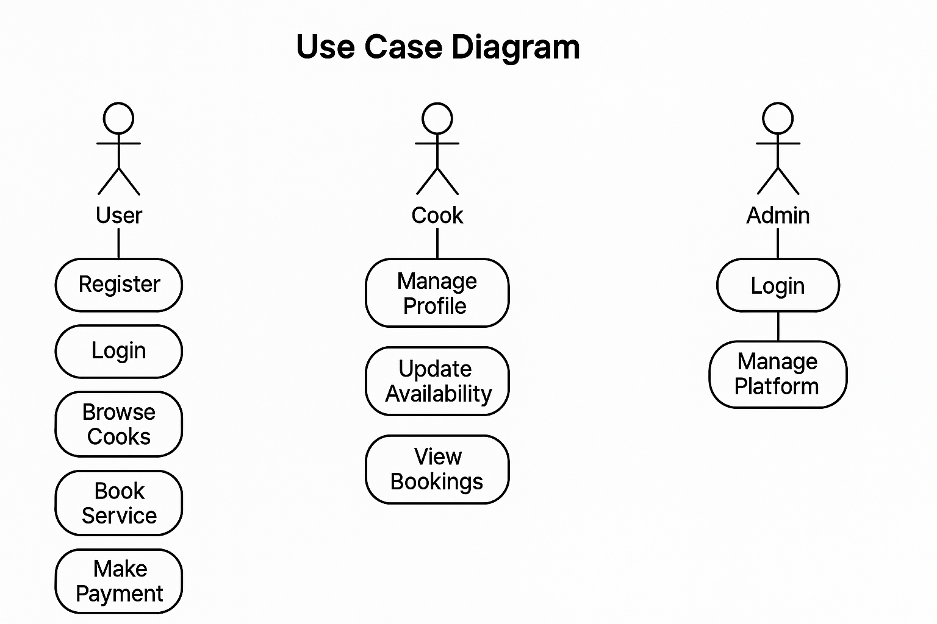

Figure 2.5 (use case model)

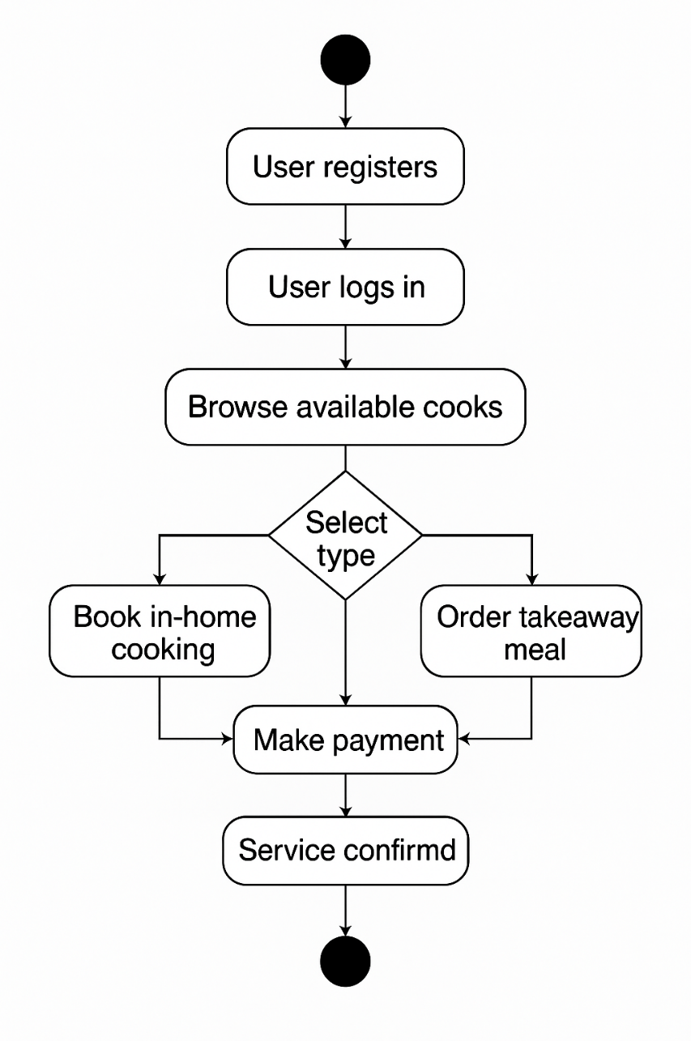
2.6 ACTIVITY DIAGRAM
Figure 3.3 (Activity diagram)

3. HomeChef Platform Specification
3.1 User Registration and Authentication
- User Onboarding: Distinct workflows for chefs and customers. Email verification, phone
OTP for security.
- Data Validation: Robust backend checks for data consistency and format adherence.
- Role-Based Access: Contextual dashboards; chefs see order management, customers see
order history and feedback tools.
3.2 Chef Discovery and Selection
- Location-Based Search: Users filter chefs by locality, cuisine, ratings, and dietary specialties.
- Profile Presentation: Chef portfolios with bios, photos, menus, certifications, and real user
ratings.
- Availability Filtering: Booking calendar synced with chef’s schedule to eliminate conflicts.
3.3 Service Booking Workflow
- Step 1: Customer selects chef, views available date/time slots, customizes order (e.g., spice
level, allergens, meal type).
- Step 2: Real-time booking confirmation with automated notifications to both parties.
- Step 3: Live status (scheduled, in progress, completed, cancelled) accessible on user dashboards.
- Modification/Cancellation: Rules for refunds, rescheduling, and communication handled via the
platform.
3.4 Payment Mechanisms
- Secure Digital Payments: Integration with UPI, cards, wallets; PCI DSS compliance.
- Transaction Flow: Funds held in escrow until service is confirmed delivered.
- Revenue Model: Platform fee deducted per transaction; transparent fee structure for chefs.

3.5 Feedback and Review System
- Post-Service Review: Both parties submit ratings and textual feedback.
- Verification: Only verified bookings can be reviewed, preventing spam/fake reviews.
- Dispute Handling: Admin tools for resolving review conflicts and mediating complaints.

3.6 Admin Controls and Dashboards
- Chef Onboarding: Admin verifies credentials, hygiene, menu quality.
- Analytics: Real-time statistics (order volume, satisfaction rates, revenue, user growth).
- Quality Audits: Admin periodically samples chef performance and customer satisfaction.

3.7 Data Flow and Interaction Diagram
- User Requests: Customers and chefs interact via web/mobile client, triggering backend API calls.
- Processing Layer: Authentication, booking, transaction, and review logic handled server-side.
- Storage Layer: Data persisted in MySQL, with caches for high-frequency queries.
- Integration Points: External APIs for maps, payment, and messaging.

  - TABLE DESIGN

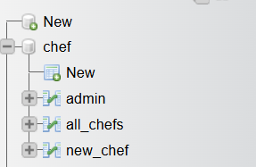

(Screen shows the Table design in database)

3.5 USER INTEFACE DESIGN

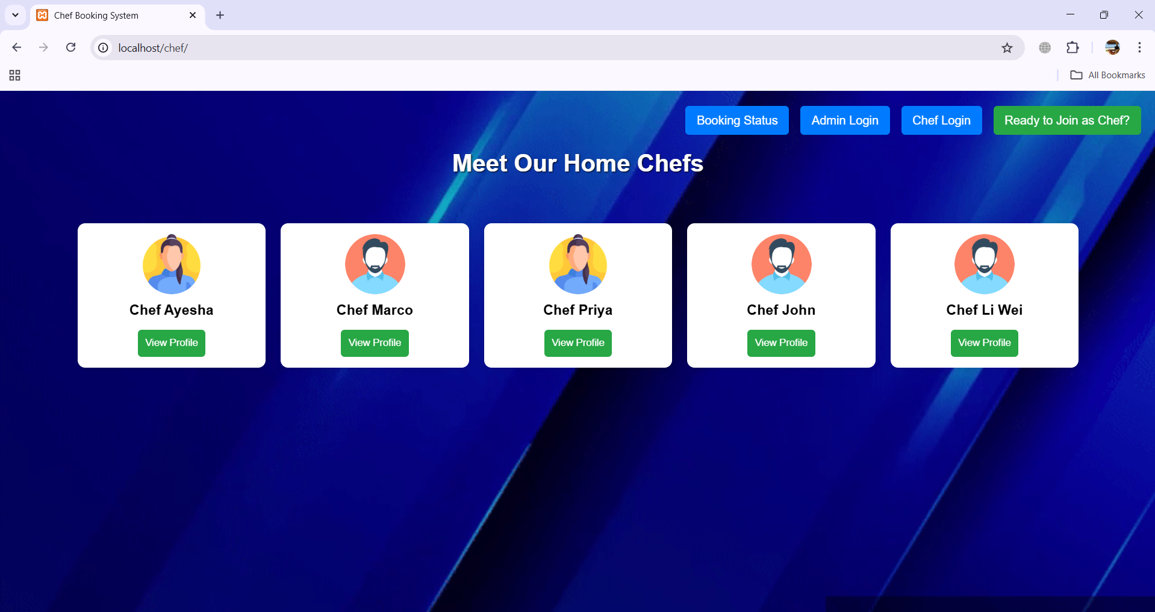

( Screen shows the main menu, where the user can see the chef profiles and choose.)
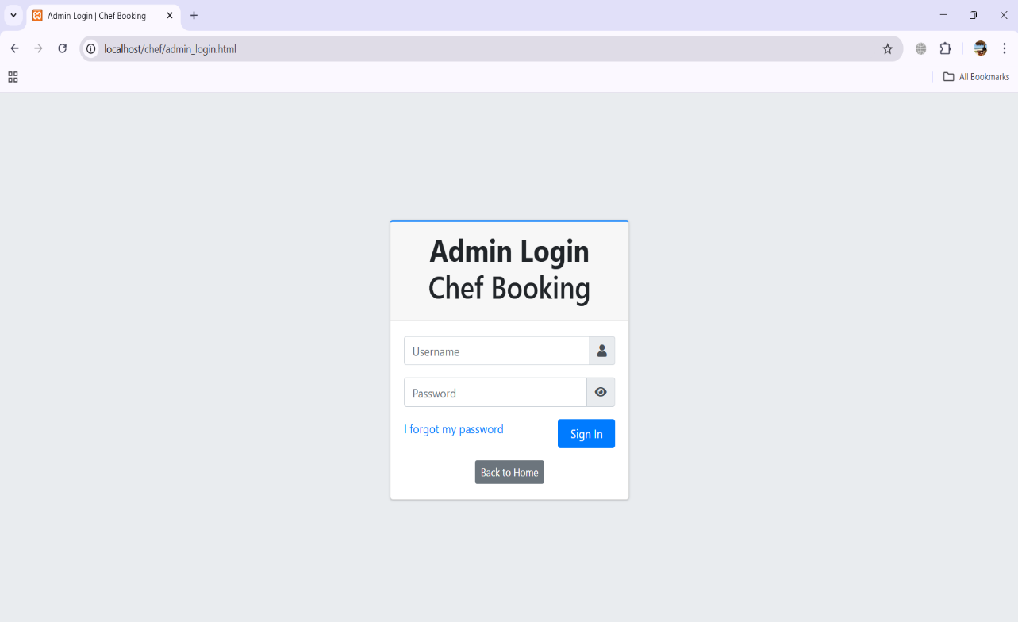

( Screen shows the Admin panel, where the admin can see the chef profiles Manage it.)

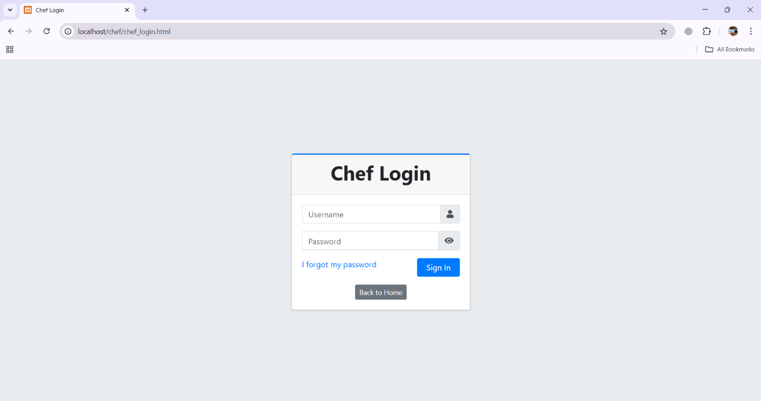
(Screen shows the Chef panel, where the chef can see their orders and Manage it.)
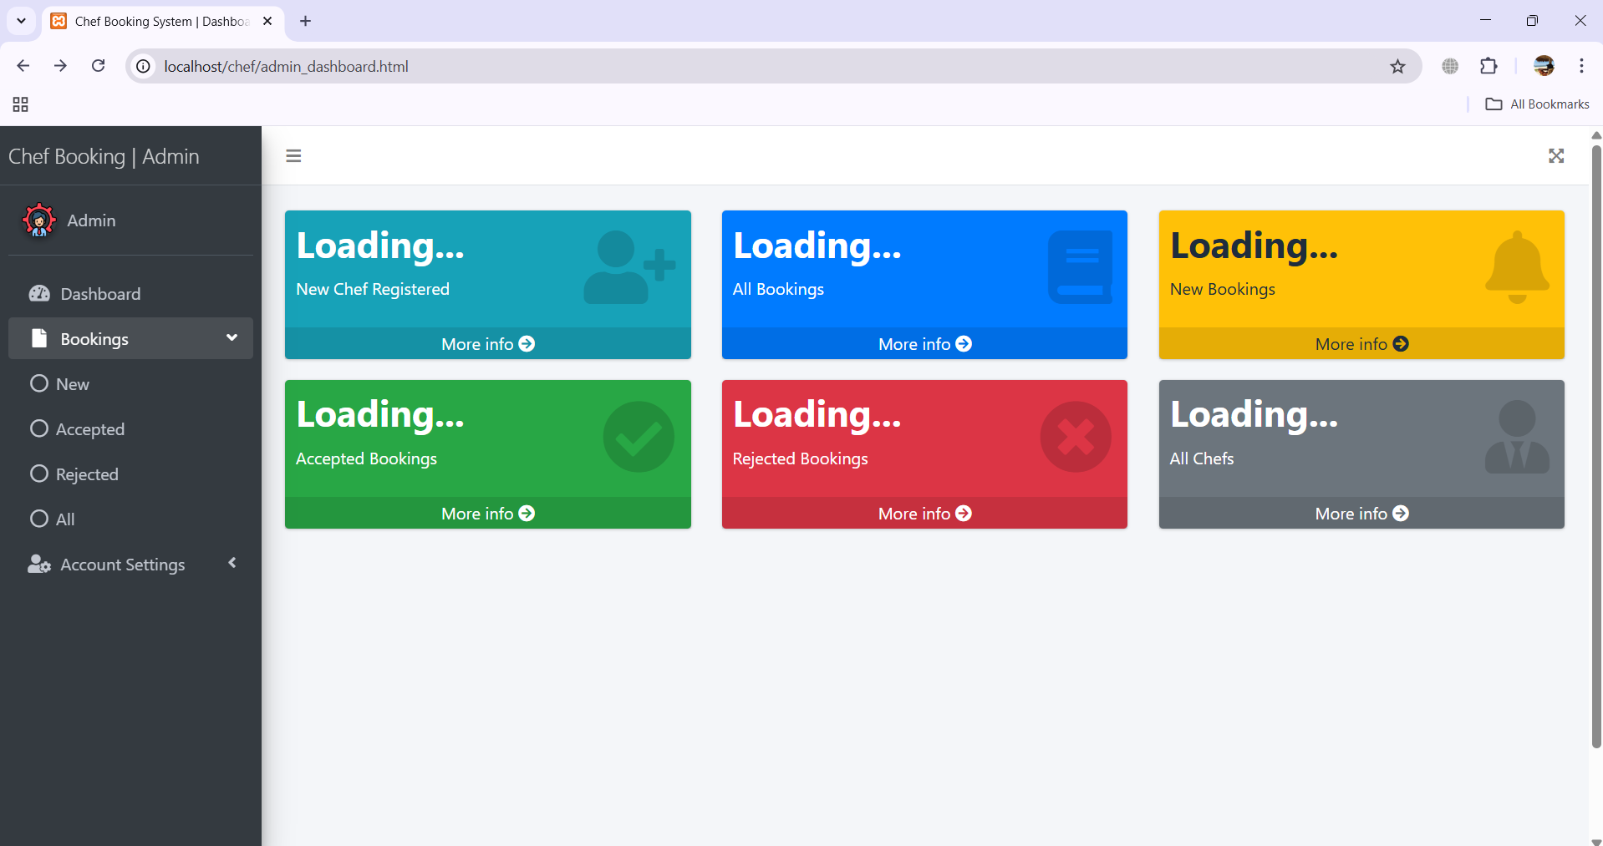

(Screen shows the Admin dashboard, where admin can manage the cooks and users.)

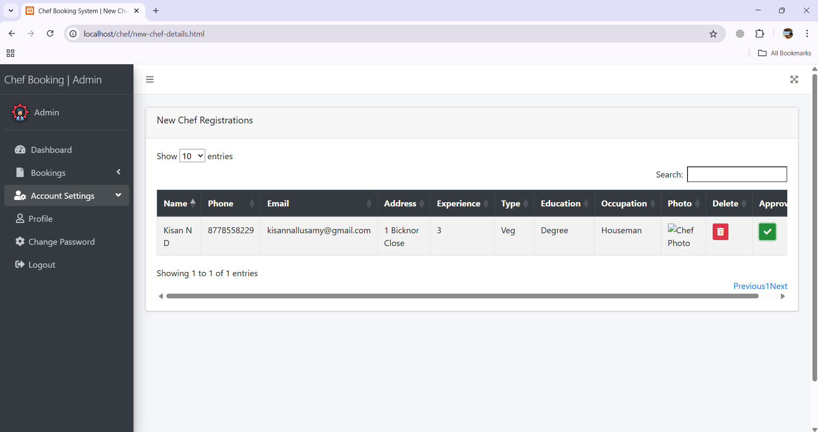
(Screen shows the registration page, where the registered chefs details will be shown to admin.)
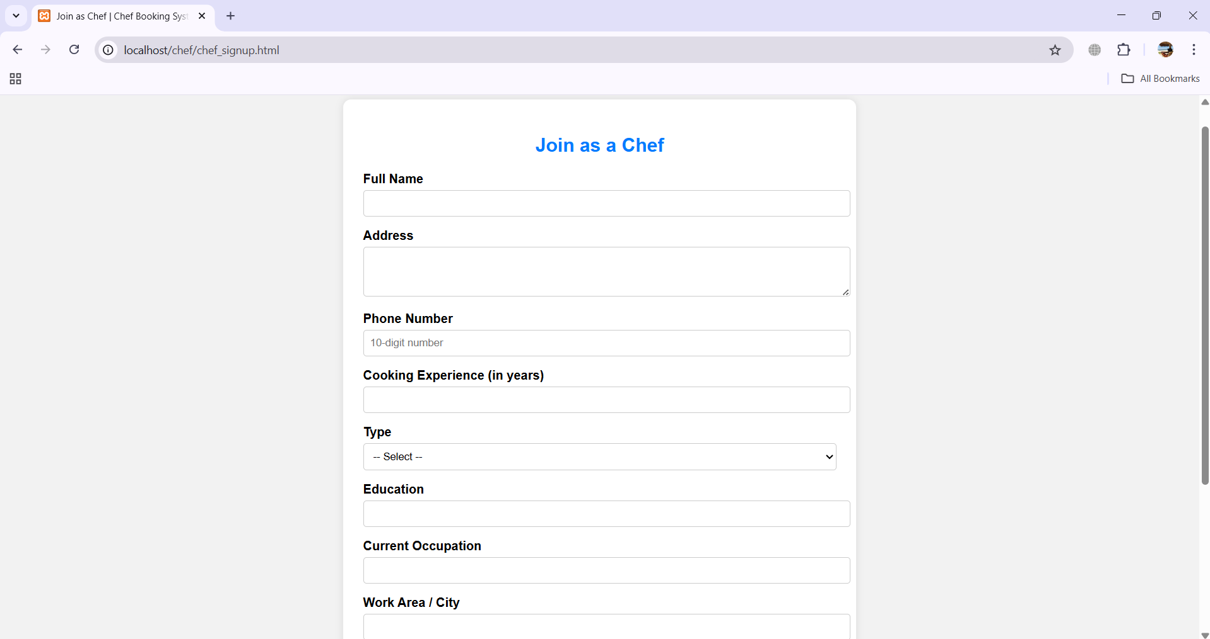

(Screen displays the registration page where new chefs can register.)

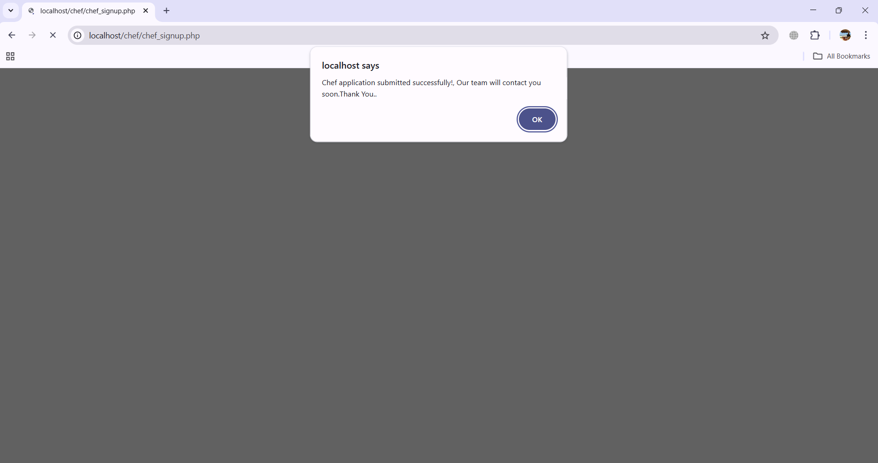
(Screen displays the message that registration submitted successfully.)
5. Related Work
5.1 Restaurant-Based Food Delivery Platforms
Choices like Swiggy, Zomato, and Uber Eats dominate urban food delivery. They aggregate commercial kitchens, focus on quick delivery, and offer limited engagement with individual cooks. These platforms have inspired features such as live tracking, digital payments, and user reviews but typically exclude home-based chefs.
5.2 Home Cooking Marketplace Solutions
Global players like EatWith and MealSharing attempt to connect diners with home-based cooks but lack penetration in many regions. Studies observe that most platforms struggle with:
- Trust in unregistered home kitchens,
- Hygiene and food safety verification,
- Scale and discovery challenges.
5.3 Community and Gig-Based Service Platforms
Uber, TaskRabbit, and Fiverr revolutionize gig work in local services. Their emphasis on digital trust, transparent feedback, and secure escrow mechanisms are directly relevant to HomeChef’s operational philosophy.

6. Discussion and Future Work
6.1 System Achievements and Social Impact
HomeChef delivers on several key fronts:
- Empowerment: Home cooks gain a sustainable income channel and digital presence.
- Community Health: Affordable, nutritious alternatives support dietary goals and reduce dependency on processed/fast food.
- Transparency: Verified profiles, genuine reviews, and admin oversight build a trustworthy ecosystem.
- Inclusion: Platform design supports multiple languages, accessibility features, and low-cost entry for small entrepreneurs.
6.2 Limitations
- Onboarding Scalability: Manual verification may bottleneck with rapid chef influx.
- Regulatory Complexity: Navigating local regulations for home food sales.
- Digital Divide: Users without strong internet access may face hurdles.
6.3 Future Enhancements
Integration with Smart Kitchen Devices
In future versions of the HomeChef platform, integrating with smart kitchen devices can significantly improve efficiency and user experience. By connecting the application with smart ovens, timers, and kitchen sensors, home chefs can automate parts of the cooking process, receive real-time alerts, and better manage their kitchen operations.
For example, the system can send reminders for order preparation time, adjust cooking settings based on the dish selected, or notify the chef when ingredients are running low. This smart integration will help chefs maintain consistent quality, reduce cooking errors, and save time—leading to quicker deliveries and increased customer satisfaction.

7. Conclusion
The HomeChef web application is a user-friendly platform that connects home-based chefs with local customers seeking fresh, homemade meals. It simplifies the process of discovering chefs, viewing menus, and placing orders through an intuitive interface. The platform not only enhances convenience for customers but also empowers home chefs—especially women and small-scale cooks—by offering them a digital space to showcase their culinary skills and earn income.Through features like location-based chef discovery, real-time booking, chef registration, and order management, HomeChef ensures a seamless and personalized food delivery experience. The inclusion of admin and sub-admin panels strengthens quality control, improves service monitoring, and ensures platform reliability.
In addition to supporting local entrepreneurship, the project promotes healthier eating by offering hygienic, home-cooked meals as an alternative to fast food. It encourages community interaction, reduces food delivery monopolies, and contributes to social and economic inclusion. By bridging the gap between home kitchens and customers, HomeChef supports Sustainable Development Goal 3 by promoting good health, and aligns with SDG 8 by fostering decent work and economic growth.

References
- Swiggy. (2024). How Swiggy works.
- Zomato. (2024). Zomato for home chefs.
- Sharma, P., & Rani, M. (2023). Connecting local food talent with digital platforms: A case study on home-based food delivery. International Journal of Modern Computing, 11(4), 213- 220.
- Kumar, A., & Singh, R. (2022). Role of location-based services in food delivery apps. Journal of Mobile Applications and Services, 9(1), 56-68.
- Bhatia, K., & Kaur, G. (2021). Impact of food tech startups on the gig economy. Indian Journal of E-Commerce and Digital Innovation, 6(3), 99-108.
- Google. (2023). Firebase for web apps: Realtime database and authentication.
- Sharma, N. (2022). User-centric design for food ordering interfaces. UX Review Journal, 5(2), 45-53.
- Kapoor, S., & Jain, V. (2020). Secure and scalable PHP & MySQL based web applications. International Conference on Web Engineering, 223-231.
- Figma. (2024). Collaborative UI/UX design.
- World Economic Forum. (2023). Digital inclusion and the future of food delivery platforms.
- Khan, A., & Patel, S. (2021). Enhancing user trust in food delivery platforms through transparency and hygiene ratings.
- Journal of Digital Consumer Behavior, 8(1), 89-97. 12. W3C. (2023). Web accessibility guidelines for inclusive interfaces.
- Bootstrap. (2024). Responsive web design made easy.
- Mozilla Developer Network. (2024). HTML, CSS, and JavaScript documentation.

